OSTINATO AS THE CONDUCTOR OF THE IDEOLOGICAL AND INFORMATIONAL COMPONENTS OF MUSIC OF THE 20TH CENTURY
The whole text was published:
Theoretical and practical questions of cultural science. Collection of scientific articles. Issue ХХV. Part III. – Melitopol': Sana, 2008.

The forms of using ostinato in the musical universum of the 20th century are extremely diverse and go far beyond the limits of constructive models. This gives rise for discrepancies in interpreting the term 'ostinato': frequently the musicologists try to determine the circle of its application in a particular study. The term 'ostinatness' used almost exclusively for the music of the 20th Century has no definition at all and is used almost infinitely. This testifies to the necessity to identify the essence of the ostinato attributes, since its definition (as the multiple repetition of melodic, rhythmic, harmonic idiom), evidently, does not require additional clarifications. Insufficient attention to the notional functions of ostinato in the musical composition as compared to the constructive and technological marks of its application gives rise to the notional and terminological inconformity.
The goal of the present article is to highlight the functions of ostinato as the carrier of ideological and informational components of the musical composition.
In the 20th Century, due to complication of the musical language, enormous for the history of music, ostinato, which had been earlier inseparable from own stereotypic forms and genres, acquires new significance. Though the form of variations of the sustained voice (more frequently, bass) remained actual, now it is not the exclusive trend, in which ostinato repetition of the musical material plays a leading role.
On the way to determination of the essential characteristics of ostinato one has to solve the problem: where is the limit, beyond which repetition, this "reference point" for any musical structure, the support for perception, the formal base for semantic processes, becomes ostinato? In what conditions the harmonic figuration, the organ point, the texture uniformity partially or fully loses its pure auxiliary assignment and begins to 'act' as an independent vivid component? The answers to these questions could be obtained by taking as the basis the structural and semantic integration as the leading peculiarity of the musical thought of the 20th Century. In this context, it is reasonable to explicate the individual form in more extended comprehension than the musical theoretical one as the material carrier of the content. Such comprehension substantially extends the horizons of theoretical interpretation, because it solves a contradictory (at first sight) mutual "conversion" of the structure and semantics. This allows the process of symbolization, 'overgrowing' with notional nuances of auxiliary applied musical terms on their way to transformation into ostinato to be considered. To analyze the qualitative transformation of the genre attribution element into the ostinant repetition we chose an example from D. Shostakovich's symphonic works.
In the F-major march from the development of the part I of the Fifth symphony, the ostinant figure is composed of the accompaniment elements underlined by the insistently repeated rhythm of the snare drum – . Note that the tone of this instrument in D. Shostakovich's symphonies is usually used to disclose the image of evil, destruction, bold aggression. This episode opens a series of grotesque, fatefully automated marches in the next symphonies – Seventh, Eighths, Elevenths. Nevertheless, note some facts, which are indicative and important for explaining determinacy of the ostinant repetition in the 20th Century.
The ostinant rhythmic figure, which is a genre attribute of the "military" march, is combined with melodic configuration: . Low-second melodic intonation does not correspond to the genre nature of the march accompaniment and creates discomfort in apprehension. This moves the specified figure to other semantic field and produces additional notional nuances. The melody identical by the rhythmic and intonational construction is one of the central elements of embodiment of the vivid and allegoric M. Musorgsky's idea in the third part – "The Trepak" of the song cycle "Songs and Dances of Death".
Commonality of image, associative and allegoric skills, the use of 'genre-related generalization' by both composers, heredity of the dance genre turn to the embodiment of pointedly non-relevant tragic images, explication by contradiction – this is only a small part of special character of the influence of M. Musorgsky's creative work on D. Shostakovich's art system. The intertextual route goes from "The Hopak" and "The Trepak" of M. Musorgsky's "Songs and Dances of Death" to, in particular, D. Shostakovich's "The Song of Misery" of the song cycle "From Jewish Folk Poetry" and the first section of the "Stepan Razin's Scaffold".
An example from D. Shostakovick's symphony illustrates the historical and dialectical process of the ostinant figure formation, which in this case becomes the element of construction of the art system of the musical composition. The rhythmic pattern is an element of organizing structure that functions as the primary metro-rhythmic repetition in the old Russian solo male dance of improvisational character (the trepak). In the 19th Century, in the context of esthetics of the Russian musical realism, the trepak became a subject of genre citation in M. Musorgsky's creative work. In "The Trepak" of the cycle "Songs and Dances of Death", the theme has two guises, i.e. as the bass figure of the fortepiano accompaniment (Example 1):

Example 1
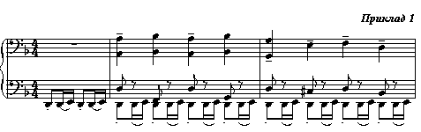
and in the rhythmic enlargement with the change of the primary interval from the major second to the minor one in the voice part (Example 2):
Example 2
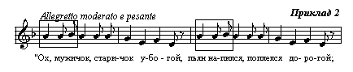
In the ostinant figure from Shostakovich's Fifth symphony, the two above elements are combined.
The bass repetition figure in Musorgsky's works could not be considered ostinato, because alone it does not provide image contradiction, i.e. it corresponds to the genre chosen by composer and makes no counteraction to the general logics of harmonic development. Semantic contradictions that form the system of allegories in the entire cycle are in the other creative dimension.
In Shostakovich's symphony, the above repetitive figure creates a multi-level semantic complex. If one proceeds with deductive method, the following historical and symbolic series is constructed:
1) the intertextual level: the rhythm as the genre attribute;
2) the artistic parallels 'Musorgsky – Shostakovich;
3) the general semantics and stylistics of Shostakovich's creative work;
4) the symbolism of thematic elements of the Fifth symphony: the figure under consideration is a rhythmic reduction of the second accompaniment theme.
The ostinato repetition of the rhythmic and intonation figure in the development of the part I of D. Shostakovich's Fifth symphony accumulates the attributes of the above semantic levels performing the activation function of simultaneous 'inclusion' of all the above components of the musical process (Example 3):

Example 3
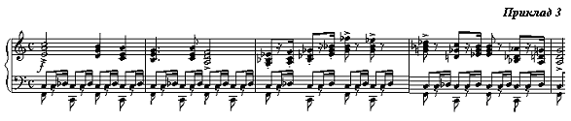
In the scenic genre music, such skills sound especially brightly and prominently. For instance, in the scene of the Crummy peasant from D. Shostakovich opera "Katerina Izmailova" the senseless accompaniment in the spirit of the operetta gallop emphasizes and enhances the grotesque expressivity of the method of characterizing the cast of characters (Example 4):
Example 4
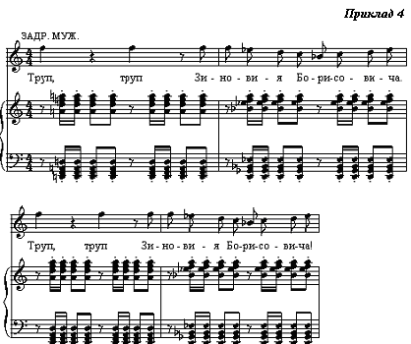
Despite the fact that accompaniment does not withstand the syntactic and harmonic logics of the voice part, its semantic mismatch and irrelevance introduce the features of ostinato in the context of particular situation. Harmony and integrity are broken and this seems to contradict a common sense.
The fragment of D. Shostakovich's Fifth symphony discloses a bilateral interconvertable process. On the one hand, repetition of a secondary by the component subordination element of the musical composition is transformed into ostinato provided it has a meaning of a symbol in the particular work. Such meaning could be formed on any level of musical semantics – from the genre attribute level to the image and association system of the particular work. On the other hand, repetition, if it has no applied constructive significance and acts as a measure to attract more attention to the specific intonation, rhythm, tone or other musical instruments, acquires the ostinato character.
Let us depict schematically transformation of the constructive method of repetition into the ostinato one using symbolization:

Constructive repetition Symbolization Ostinato
(connotation)

Construct now a similar schematic view of the second of specified methods of transforming the constructively conditioned repetition into the ostinato:

Constructive element Non-constructive Symbol
(ostinato) repetition

Let us trace the action of the above scheme on the example of the fragment of S. Prokofiev's fortepiano piece "Obsession". In middle voices of the musical texture, a figuration sounds against the background of the 'frozen' chords, being a drawn tremolo. Pertinacious repetition brings this element of the texture to front. Thus, this secondary (at first glance) musical component acquires features of ostinato due to the 'aggressive' repetition (Example 7):
Example 7
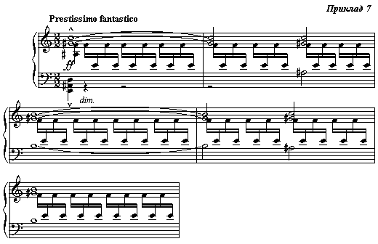
Let us emphasize additionally that both examples (from "The Etude-Picture" and "Obsession") show not the ostinato, but the ways to assign the ostinato features to the particular elements of musical language. This process proceeds in two paths: i) due to the increase of information capacity and, thus, symbolization of the constructive repetition, and ii) by non-constructive repetition of separate elements.
Two methods of formation of ostinato as the element of the musical language are not mutually exclusive. Especially, this concerns the first of them, i.e. the symbolization process. If one excludes an inapplicable repetition from it, this, in fact, means that of the repetition at all, which is apriori impossible. A different pair of shoes is repetition as the method of semantization of the musical material: this action is an element of the symbol formation process. Thus, we obtain the grounds to combine the above methods of forming ostinato into an integral system:

Constructive repetition Symbolization Ostinato
(connotation)

Constructive element Non-constructive Symbol
(ostinato) repetition

If one combines the second and the third links of this logic series, we obtain two pairs of identities: symbolization – ostinato repetition and ostinato – symbol.
Let us obtain the answer to the question raised in the beginning of this article. Ostinato should be considered the repetition of the same sound, melodic or rhythmic figure, tone, harmony and texture, constant during a certain period time, in case when they have independent notional meaning with respect to other elements present simultaneously in the musical composition (or its part). Only under such conditions one may speak about ostinato, not repetition.
Ostinato repeatability could not be the legitimate result of implementation of the chosen genre and form, except for those based on it. This is always a fruit of the artist's arbitrary choice – 'I want to do so, but it could be done in other way', not the regularity 'this must be done so, not in other way'. The basic musical and imaginative peculiarities of ostinato result from this. The notional, semantic apartness is formed as early as in the baroque genre of passacaglia: an opposition 'the bass voice – the upper voice' as a symbol of opposition of terrestrial and celestial origins; on the level of musical expression – the contrast of statics and dynamics, slowdown and motion. Further this has been developed in the skills of enrichment of psychological characteristics of the image by combining the genre and stylistic attributes, which, at first sight, seem to be incompatible. Being used, the rhythmic and intonational repeatability as the genre attribute, even not contradicting the general development of the form or harmony, is perceived as ostinato, since the connotation process takes place being enriched by the additional conceptual/notional parameters.

